Spanning Sets

Definition of linear combination:
Let 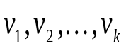 be vectors in a real vector space V. A vector 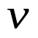in V is called a linear combination of if
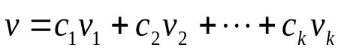,
where 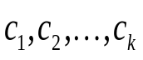.

Example:

Let
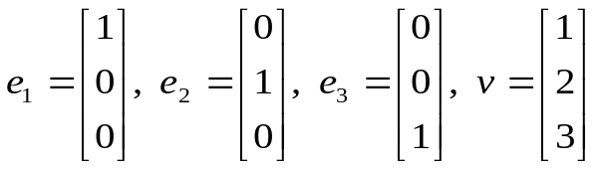.
Since
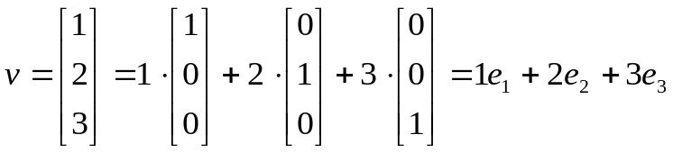,
is a linear combination of 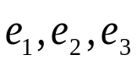.

Example:

Let
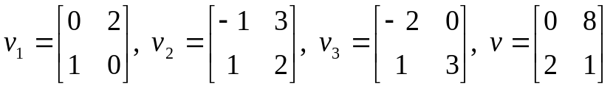
be vectors in the vector space consisting of all 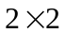 matrices. Then,
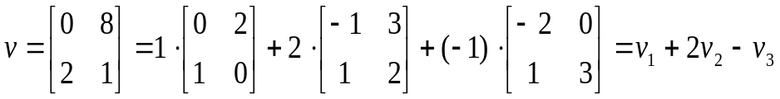.
That is, is a linear combination of 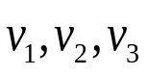.

Example:

For linear system
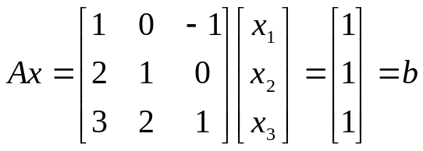.
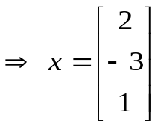 is a solution for the above linear system. Thus,
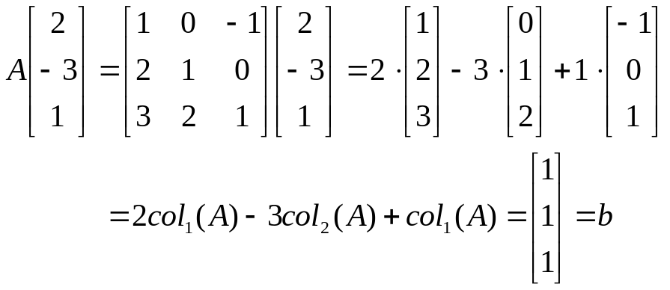
That is, 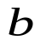 is a linear combination of the column vectors of A,
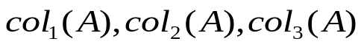.

Note:
For a linear system 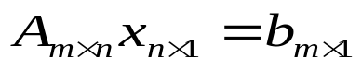, the linear system has solution or solutions  is a linear combination of the column vectors of A,
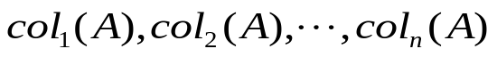.
For example, if 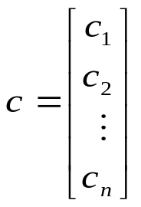 is a solution of , then
.
On the other hand, the linear system has no solution is not a linear combination of the column vectors of A

Example:

Is the vector 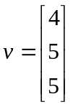 a linear combination of the vectors
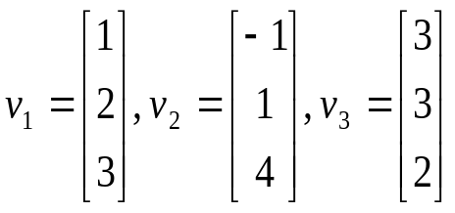.

[solution:]

We need to find the constants 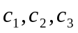 such that
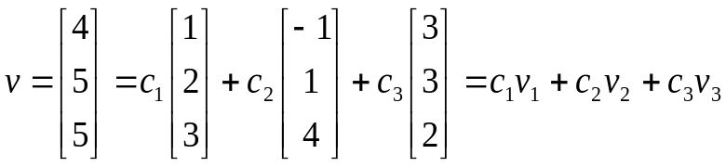.
we need to solve for the linear system
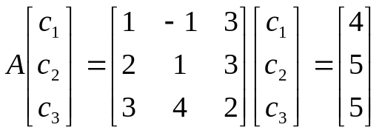.
The solutions are
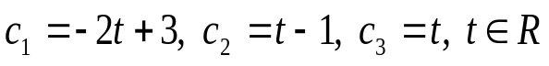.
Thus,
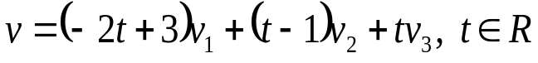
is a linear combination of with infinite number of expressions.

Example:

Is the vector 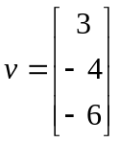 a linear combination of the vectors
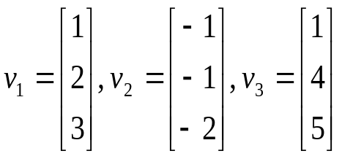.

[solution:]

We need to find the constants such that
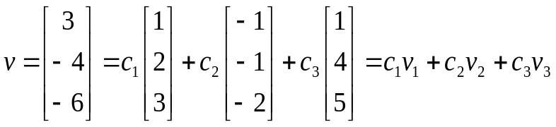.
we need to solve for the linear system
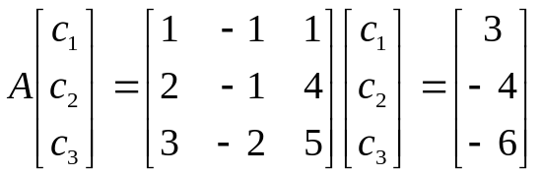.
The linear system has no solution.
is not a linear combination of

Note:
Let 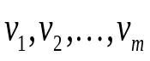 and be vectors in 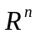 and let A be the matrix with column vectors 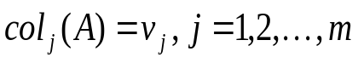. Thus,
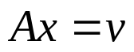 has solution or solutions is a linear combination of .
has no solution is not a linear combination of .

Definition of spanning set:
Let 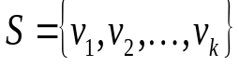 be a set of vectors in a real vector space V. Then, the span of S, denoted by 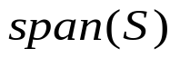, is the set consisting of all the vectors that are linear combinations of . That is,
.

If 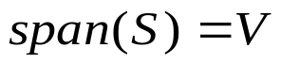, it is said that V is spanned by S or S spans V.

Example:

Let
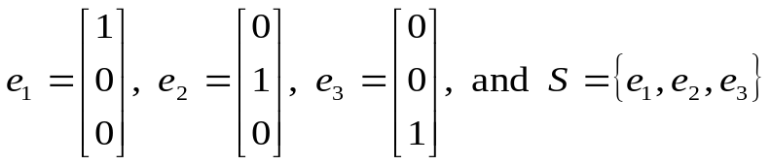.
Then,

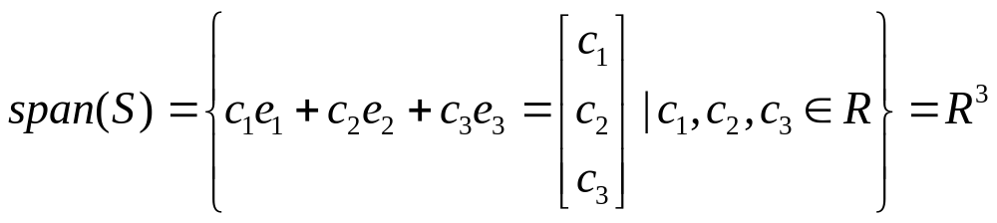,

Example:

Let
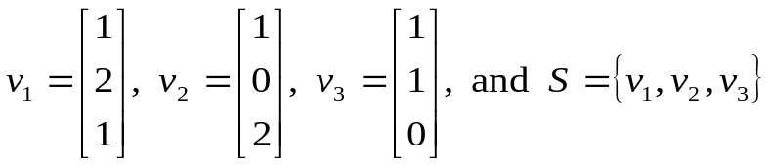.
Does 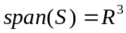?

[solution:]

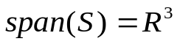 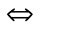For any vector 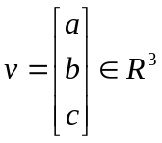, there exist real numbers such that
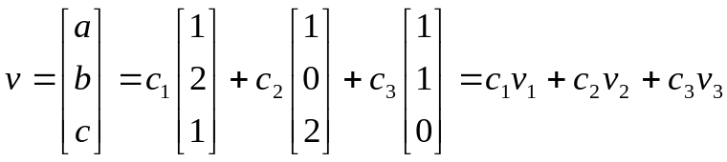.
we need to solve for the linear system
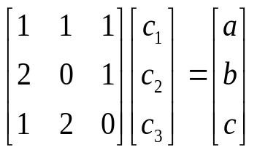.
The solution is
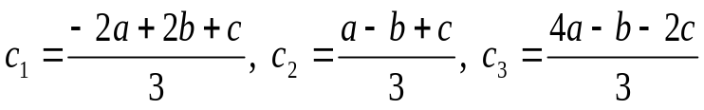.
Thus,

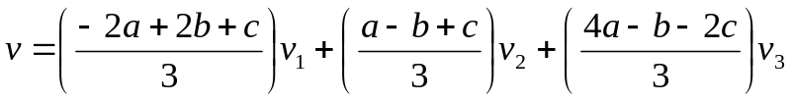.
That is, every vector in 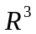 can be a linear combination of 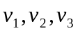

Important result:
Let be a set of vectors in a real vector space V. Then, is a subspace of V.

